Clover Instructions

# Power Up

1. Turn ‘head’ and speaker on.

1. Turn Remote Control On

1. Insert Black and Decker batteries – following order on batteries and robot

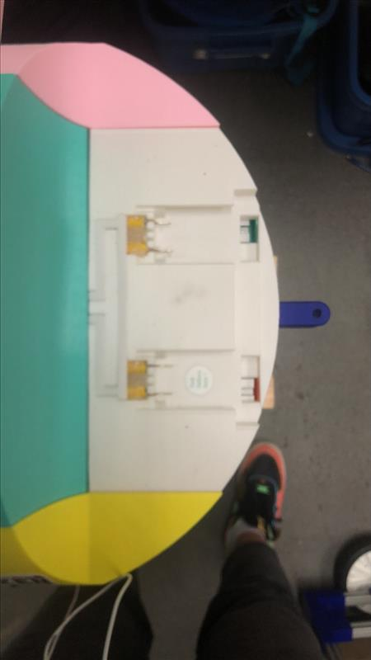

1. ‘Arm’ (Calibrate) Motors. Flick switch down, once beep is heard return to original position. NOTE ensure throttle is at most down position.

Throttle down (Zero) position.

# Remote Instructions

CALIBRATION SWITCH. FLICK DOWN ONCE AT POWERUP. ONCE BEEP IS HEARD RETURN TO ORIGINAL POSITION

SPIN TO SWITCH BETWEEN FORWARD AND REVERSE – ENSURE ROBOT IS STATIONARY

MATHS MODE –

MOVE ALL THE WAY DOWN AND UP TO ASK THE QUESTION AND INITIATE ANSWERING SEQUENCE

CHATBOT –

SIMON SAYS, MOVE ALL THE WAY DOWN AND UP FOR THE NEXT COMMAND

NOTE – TRY NOT TO TOUCH THE BUTTONS BENEATH THE BLACK ELECTRIC TAPE. THIS WILL OFFSET THE CALIBRATION ON EACH JOYSTICK. MAY CAUSE PROBLEMS STEERING ECT.

THROTTLE

TURNING

# Charging Instructions

* Plug both black and decker batteries in after use, even if they did not die.
* Do not reuse after plugging in until fully charged. This is when the green light on the charger stops flashing.
* All good to leave charging overnight.
* Plug ‘head’ in.

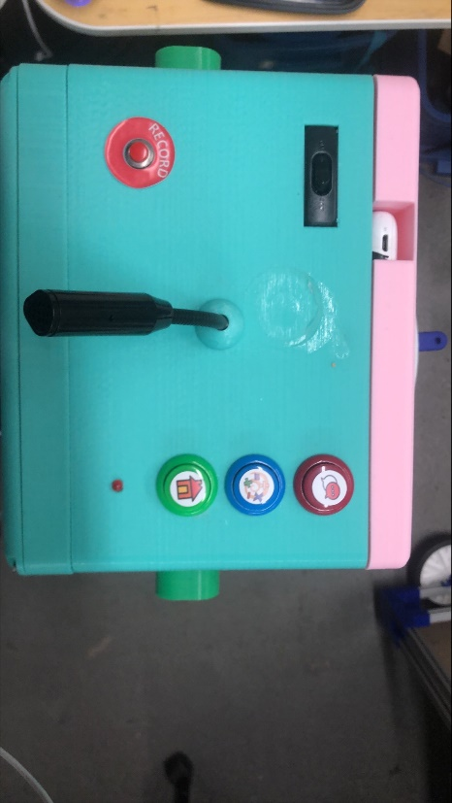

# Applications

Home Screen:

Use the mouse to select an application.

# Main Program:

The main program consists of the ‘face’ animation. Within this application the buttons on the top of the head can be used to navigate to different modes.

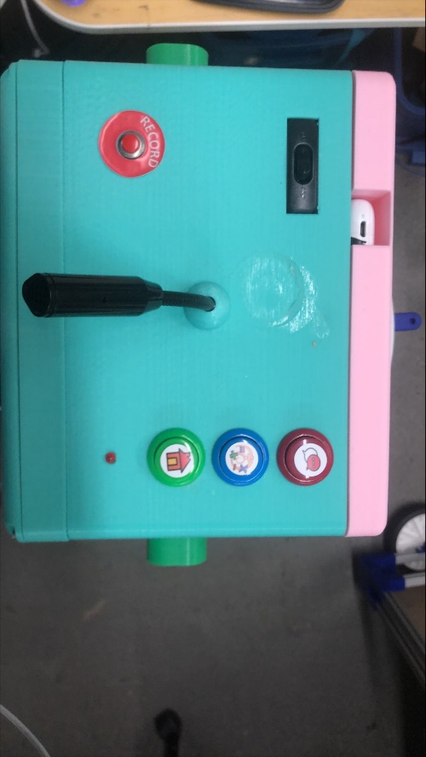

1. Initial screen:

The default mode is just the animation. The eyes will bounce while driving and she will make a driving ‘R2D2’ like noise.

1. Chatbot

This is the first red chat button. Basic instructions will be displayed on the robot.

To speak to clover, to record button is pressed. Once the red LED lights, clover is listening… talk now !

Once the LED turns off, clover will think of her response and speak back.

Simon says can also be played here. Please refer to remote instructions to play this game.

1. Maths Game

This is the second blue maths button.

Ask the kids to initially select a character (animal from the bottom of the screen)

To answer a question press the record button.

Say the answer. If the answer is not being recorded ask the kids to say “the answer is…”. This works better.

If the answer is correct, clover will prompt for a character selection. Wait for the LED to light (don’t press record again), say your character/animal.

Rather than pressing record the remote control can be used. Please refer to the RC controls section.

To navigate out of the separate modes use the green home button. Pressing this while in the base mode will exit the application.

# Quiz Me ! Application

This application is designed to answer knowledge based questions. To use just press record and once the LED lights, ask your question.

A point to note, this is a web scraper and so hard to filter completely. There are prompts for the kids on this application, it works like google and so if the kids ask something inappropriate, they may get an inappropriate response.

Some sample questions it is designed for would be :

‘What is the capital of France?’

‘How many planets are there?’

‘What is the fastest animal?’

As before, use home to exit this application.